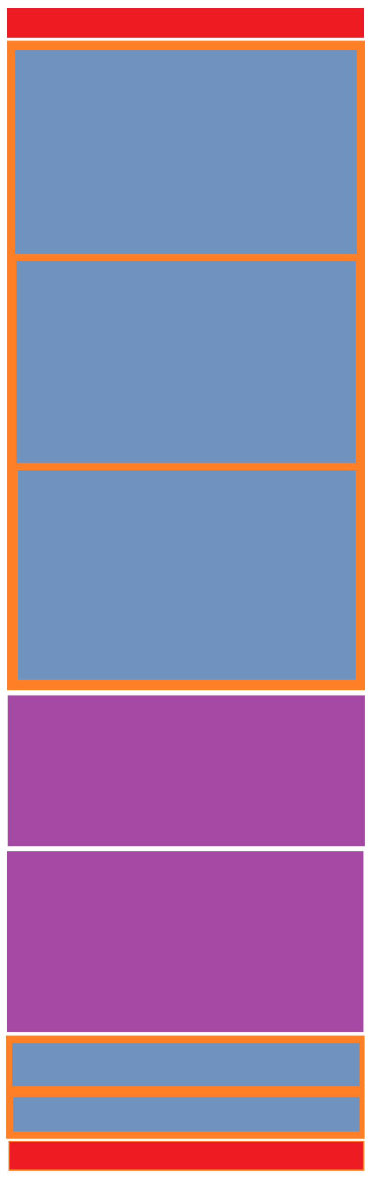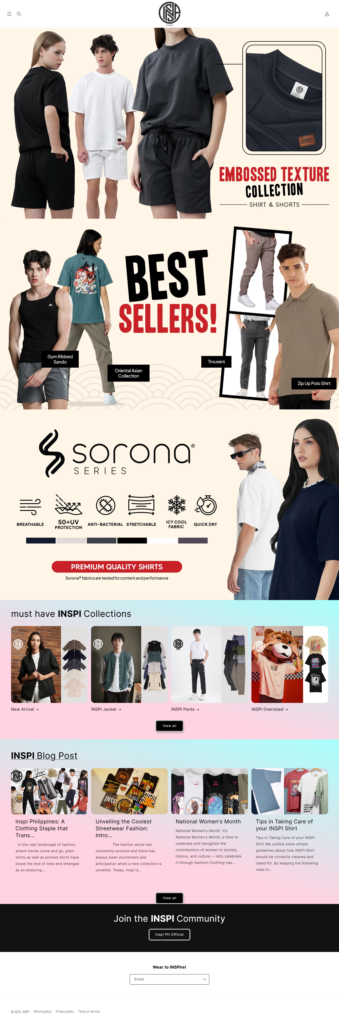

**SUB2**

**SUB1**

**COMMUNITY**

**BLOG SECTION**

**COLLECTIONS SECTION**

**MAIN SUB3**

**MAIN SUB2**

**MAIN SUB1**

MAIN

**FOOTER**

**HEADER**

1. HEADER
   1. LOGO
   2. USER ICON
   3. MENU BUTTON
   4. SEARCH ICON
2. MAIN
   1. FEATURED COLLECTION 1
   2. FEATURED COLLECTION 2
   3. FEATURED COLLECTION 3
3. COLLECTIONS SECTION
   1. HEADING
   2. PICTURES
   3. VIEW ALL BUTTON
4. BLOG SECTION
   1. HEADING
   2. PICTURES
   3. VIEW ALL BUTTON
5. COMMUNITY SECTION
   1. FACEBOOK COMMUNITY
   2. NEWSLETTER SUBSCRIPTION
6. FOOTER
   1. COPYWRITE
   2. POLICIES
   3. T&C

Thought Process:

I first looked at it at a bird’s eye view like looking from afar, seeing the big blocks and then checking if there are divisions within those blocks. Knowing semantics also helped as I also group them according to their sections: Heading, Main, Footer.